**Question#04**

The attached image contains the illustrated star schema for **Fitness Retail Data Warehouse**.

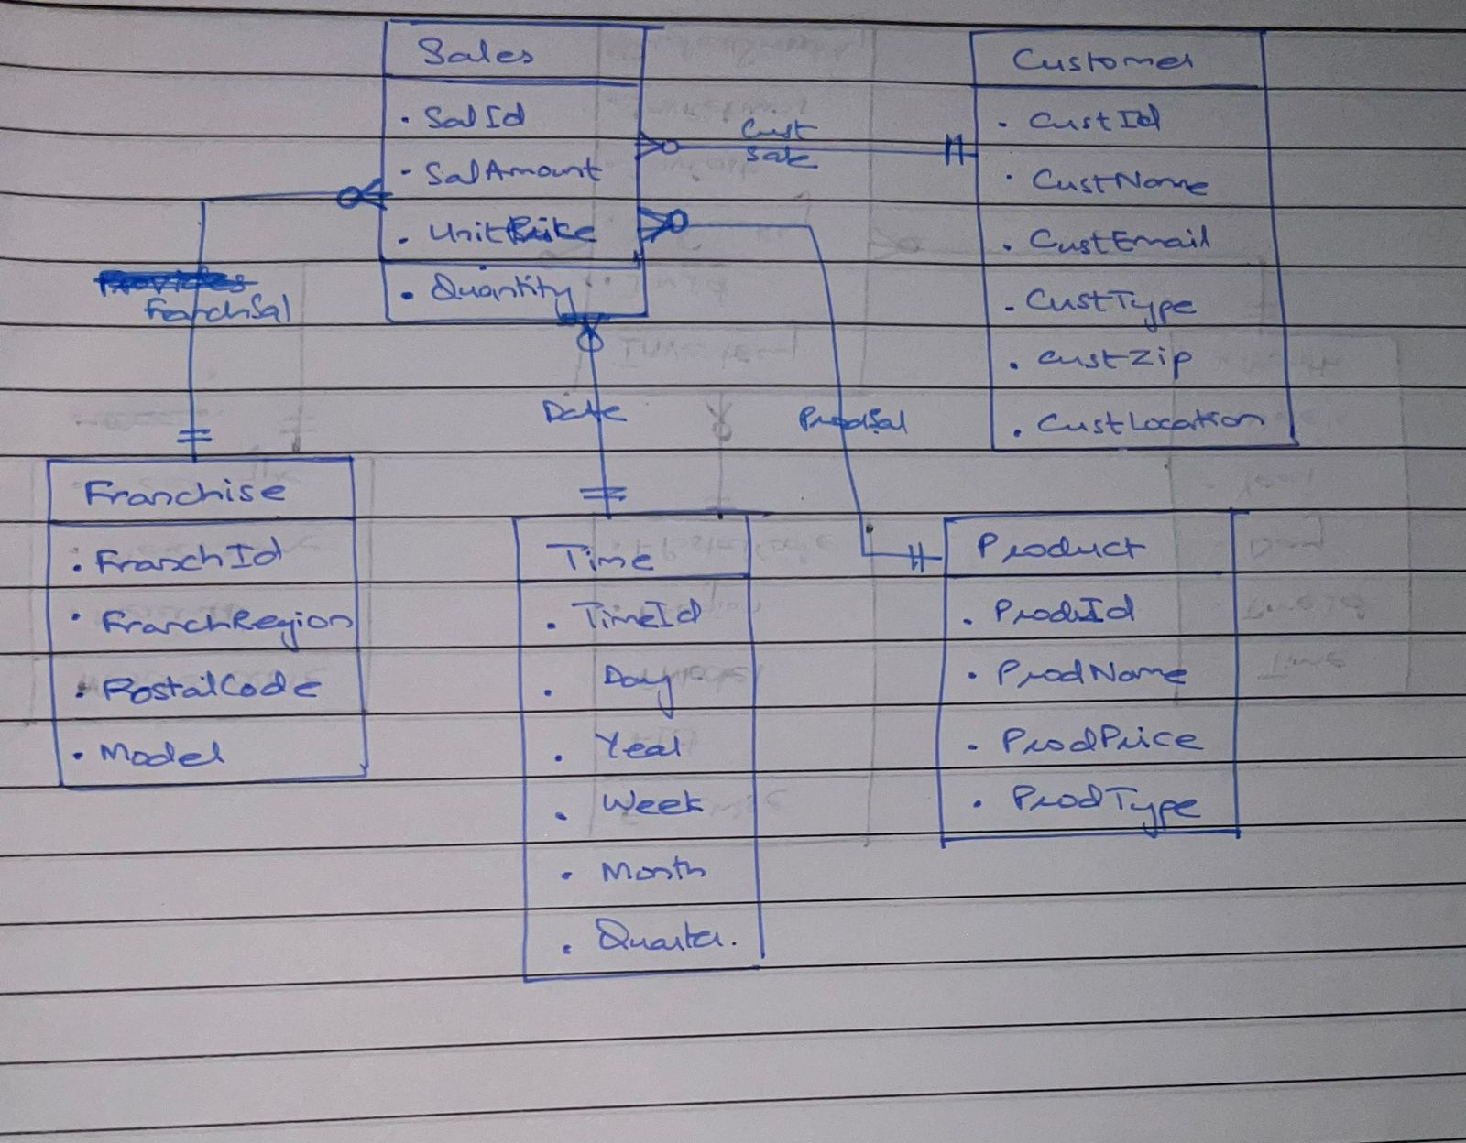

* Franchise dimension contains information about the locations of the franchise where inventory is stored or sold.
* Time dimension contains information about the time periods for which inventory data is collected.
* Sales is the fact table that contains information about the sales amount and the quantity.
* Customer dimension contains all the information about the members and customers who have used any service/product.